# 

# **Department of Computer Science and Engineering Islamic University of Technology (IUT)** A subsidiary organ of OIC

# **Laboratory Report**

# CSE 4412: Data Communication and Networking Lab

## 

## **Name: Rowshan Mannan Oni Student ID: 210042145 Section: SWE Semester: SUMMER Academic Year: 2023-2024**

**Date of Submission:**

### **Title:** Configuring and Verifying of RIP and OSPF in a network topology.

### **Objective**:

1. Describe the concept of dynamic routing
2. Explain disadvantages of RIPv1 and improvement in RIPv2
3. Configure Routing Information Protocol (RIP) in a network topology following given

specifications

### 

### **Devices/ software Used**:

* + - 1. Cisco Packet Tracer

### **Theory:**

*(Explain in brief the listed keywords)*

**Routing Information Protocol (RIP)**

The Routing Information Protocol (RIP) is one of the oldest distance-vector routing protocols used in computer networking. It's designed for small to medium-sized networks and operates within a single autonomous system (AS). RIP's primary purpose is to exchange routing information between routers to enable them to dynamically learn and update their routing tables.

**Forwarding Table used in RIP**

In RIP (Routing Information Protocol), routers use a forwarding table, also known as a routing table, to determine the next hop for forwarding packets to their destinations. The forwarding table in RIP contains information about known networks, along with the associated next-hop routers and metrics (usually hop count).

**Hop Count as cost**

In the Routing Information Protocol (RIP), hop count is used as a metric to determine the cost of reaching a destination network. Each router counts the number of hops (i.e., intermediate routers) between itself and the destination network, and this hop count serves as the basis for determining the best path to reach that network.

**Timers in RIP**

In the context of networking, specifically in the Routing Information Protocol (RIP), timers play a crucial role in determining the behavior and efficiency of the protocol. RIP is a distance-vector routing protocol used to exchange routing information between routers within an autonomous system.

### **Diagram of the experiment:**

*(Provide screenshot of the final network topology. Make sure to label the network components.)*

**Task #01:**

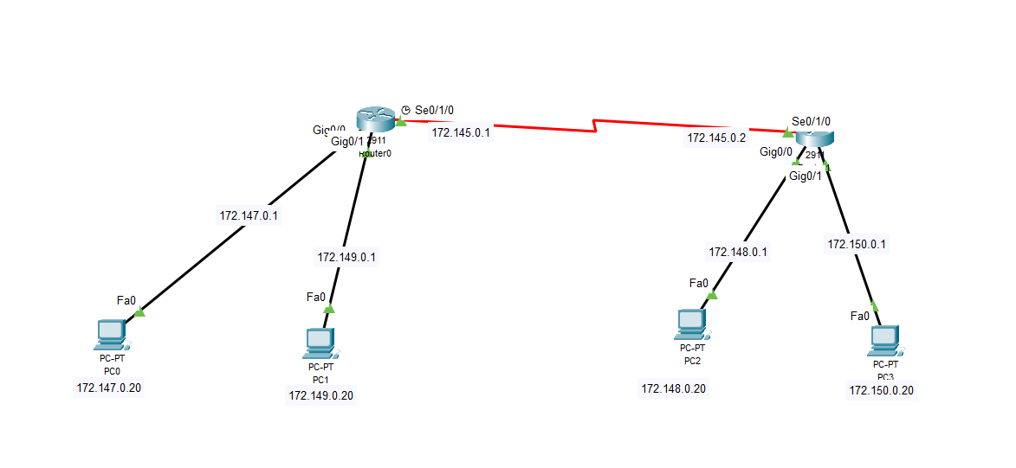

**Task #02:**

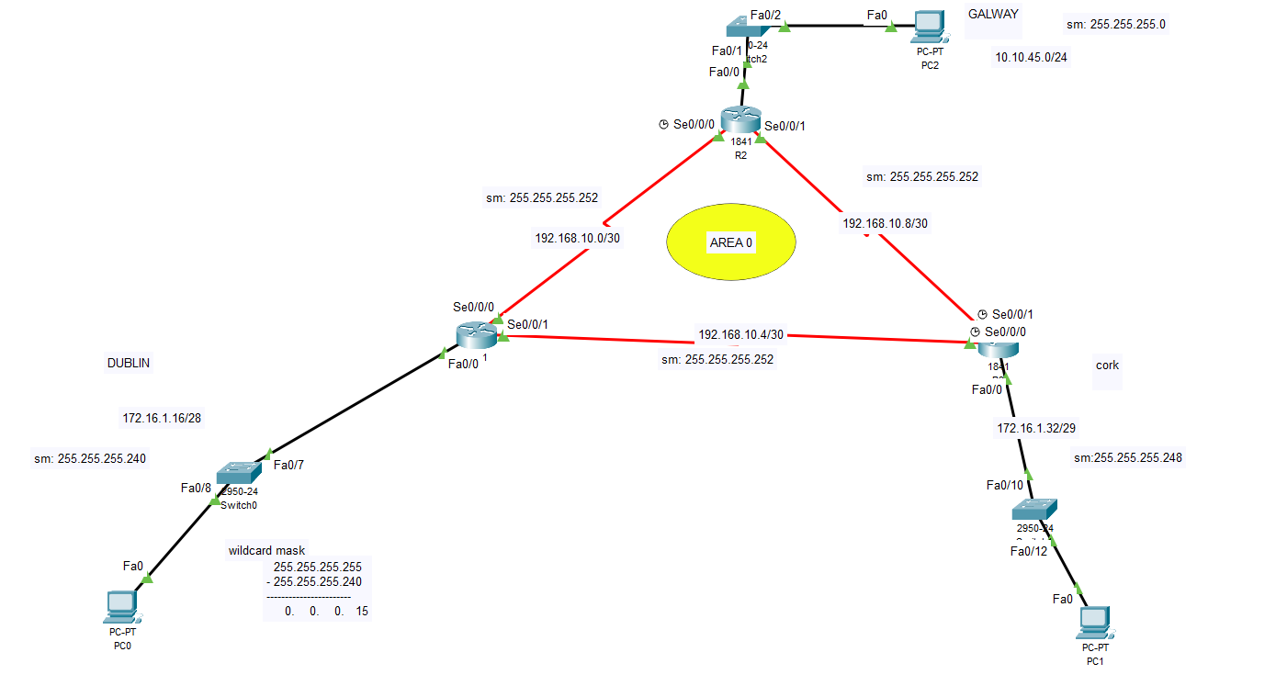

### **Working Procedure:**

***(****Explain in brief how you completed the tasks. Provide necessary screenshots of used commands for each task.)*

**Task #01:**

Assign IP Addresses:

**R1:**

Serial 0/0/0 (DCE): 172.145.0.1/27

FastEthernet 0/0: 172.147.0.1/25

FastEthernet 0/1: 172.149.0.1/25

**R2:**

Serial 0/0/0 (DTE): 172.145.0.2/27

FastEthernet 0/0: 172.148.0.1/26

FastEthernet 0/1: 172.150.0.1/26

R1(config)# router rip

R1(config-router)# version 2

R1(config-router)# network 172.145.0.0

R1(config-router)# network 172.147.0.0

R1(config-router)# network 172.149.0.0

R2(config)# router rip

R2(config-router)# version 2

R2(config-router)# network 172.145.0.0

R2(config-router)# network 172.148.0.0

R2(config-router)# network 172.150.0.0

**Task #02:**

Firstly, I configured the whole setup and assigned ip as given below :

R1 def gateway

Fa0/0 172.16.1.17 255.255.255.240 N/A

S0/0/0 192.168.10.1 255.255.255.252 N/A

S0/0/1 192.168.10.5 255.255.255.252 N/A

R2

Fa0/0 10.10.45.1 255.255.255.0 N/A

S0/0/0 192.168.10.2 255.255.255.252 N/A

S0/0/1 192.168.10.9 255.255.255.252 N/A

R3

Fa0/0 172.16.1.33 255.255.255.248 N/A

S0/0/0 192.168.10.6 255.255.255.252 N/A

S0/0/1 192.168.10.10 255.255.255.252 N/A

PC1 NIC 172.16.1.20 255.255.255.240 172.16.1.17

PC2 NIC 10.10.45.10 255.255.255.0 10.10.45.1

PC3 NIC 172.16.1.35 255.255.255.248 172.16.1.33

**THEN I’ve configured all router for OSPF:**

**For router 1: (Router ID : 20.20.20.20)**

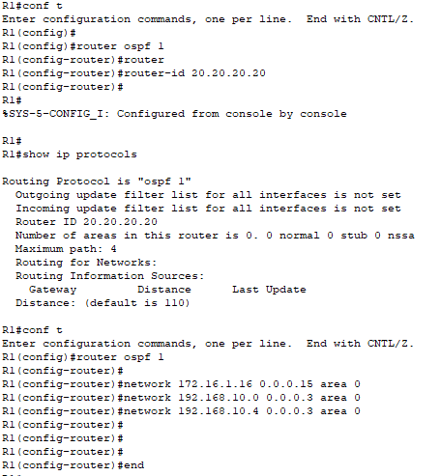

**For Router 2:**

**I’ve given the router id : 30.30.30.30 for router 2**

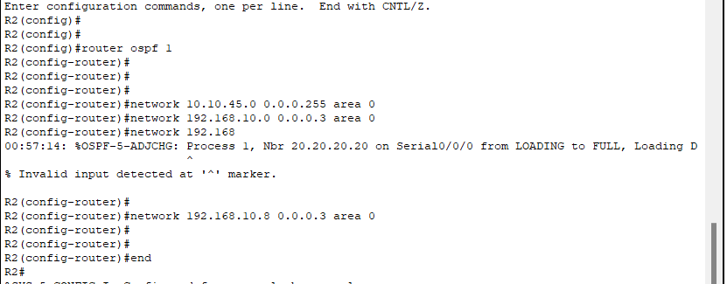

**for router 3: (router id : 40.40.40.40)**

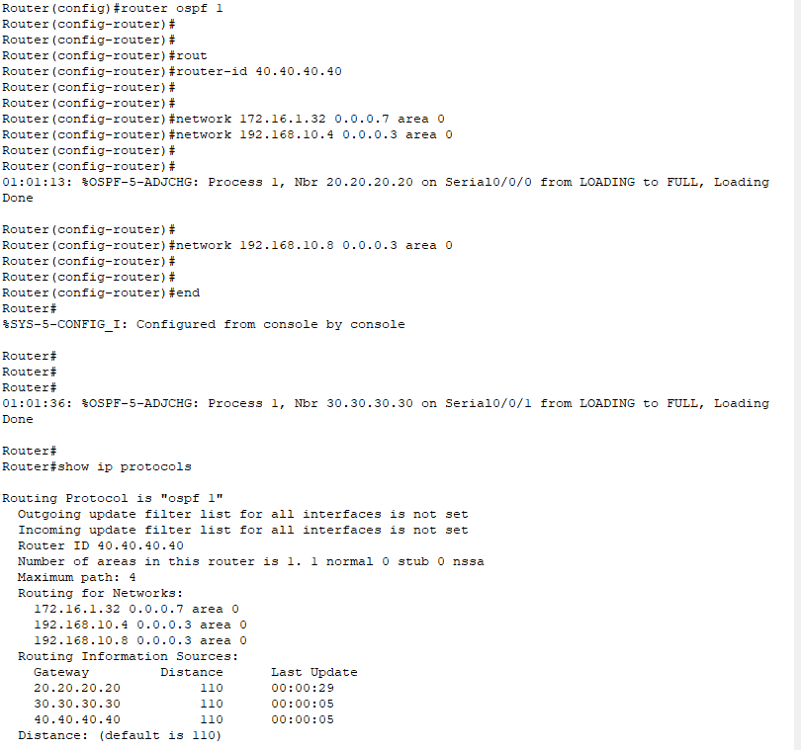

### **Q/A for the tasks:**

***(****There were many q/a sections inside the task pdfs. Copy the questions and your answers here.)*

**Task #02:**

**Note: I’ve configured the router id myself, otherwise the highest ip in the router interfaces would be the router id.**

**What is the router ID for R1?**

**20.20.20.20**

**What is the router ID for R2?**

**30.30.30.30**

**What is the router ID for R3?**

**40.40.40.40**

**When the router is reloaded, what is the router ID for R1?**

Note: I haven’t created any loopback interfaces, thus I didn’t had to restart my ospf.

If I didn’t set the router Id before handed myself. I would’ve created loopback interfaces in all the routers and the ip of the loopback interfaces would be the router id for respected routers.

**When the router is reloaded, what is the router ID for R2?**

Note: I haven’t created any loopback interfaces, thus I didn’t had to restart my ospf.

If I didn’t set the router Id before handed myself. I would’ve created loopback interfaces in all the routers and the ip of the loopback interfaces would be the router id for respected routers.

**When the router is reloaded, what is the router ID for R3?**

Note: I haven’t created any loopback interfaces, thus I didn’t had to restart my ospf.

If I didn’t set the router Id before handed myself. I would’ve created loopback interfaces in all the routers and the ip of the loopback interfaces would be the router id for respected routers.

### **Observation**:

I’ve observed that the router Id is automatically picked up from the highest ip among the interfaces. And if I create a loopback then router Id is the loopback interfaces ip.

### **Challenges (if any):**

Had challenges when, I tried to do the task without reading the PDF.